Eudey, Econ 302, January 2019
Forecasting and the Aggregate Production function Reference “Macroeconomics in Action” text boxes in Chapter 3
Reading
These notes complement the three “Macroeconomics in Action” text boxes in Chapter 3:
- Economic Forecasting and the Financial Crisis
- Jobless Recoveries
- The Great Moderation and the 2008-2009 recession
The Aggregate Production Function
You may recall from your introductory macro course that long run GDP depends on the amount of technology, capital, and labor available in the economy, and so a forecast of the trend level of GDP is really a forecast of those inputs into the aggregate production function:
GDP = f(labor input, labor productivity)
This particular production function is pretty bare bones—it doesn’t even distinguish between the many things that make labor productive, like how much capital people have to work with, the quality of management, technological progress, education levels, work-experience, etc. But even this bare-bones production function can help us understand a lot about the economy and it is the one we’ll be working with in Chapters 4-6.
For example—take a look at this time series for (real) GDP growth. Note that the average growth rate for GDP was highest in the early part of the sample (imagine drawing a line through the middle of the growth rates in each decade), with growth rates at one time averaging close to 3% per year and now averaging around 2% per year.

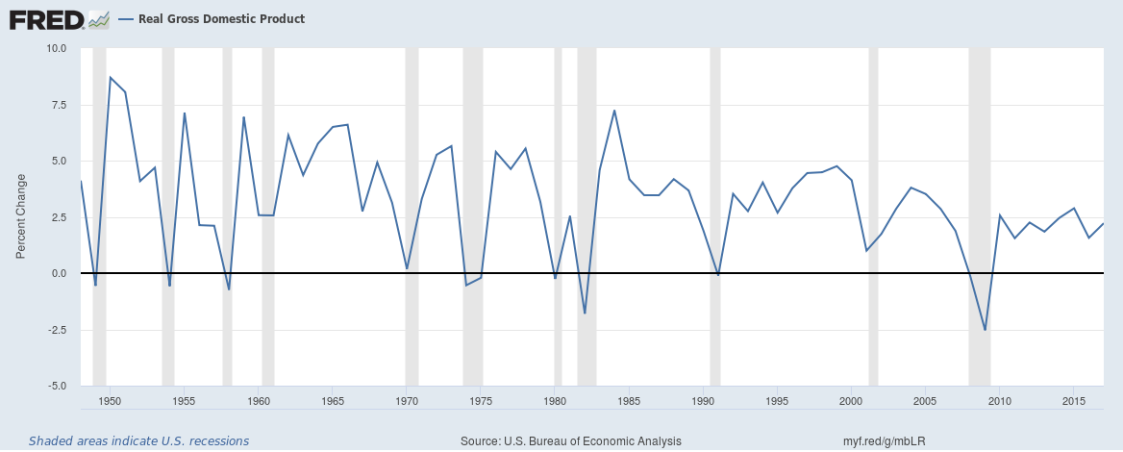

What happened? Why isn’t the economy as strong now as it was then? The Congressional Budget Office (CBO) has put together a useful graphic that lays out the contributions of labor input and labor productivity to overall GDP growth. The Great Recession (2008-2011) had a negative impact on capital accumulation and labor productivity generally, but the real hit to GDP growth and to the GDP forecast comes from the slowdown in the contribution of the labor input itself.
Source: CBO, August 2018
More than half of the rapid GDP growth in the mid-20th century came from growth in the number of people producing output. There were two important sources of that sustained growth in labor input:
- Changes in women’s labor force participation rates. Women’s labor participation rates levelled off in the mid-1990s and so that is no longer a growth factor
- There was a baby boom from 1950-1964, with additions to the workforce (both male and female) contributing to more GDP growth in the latter half of the 60s through the mid-80s. Population growth has slowed since and there has been a marked slowdown in birth rates since the Great Recession.
All other things being equal, the slowdown in US population growth translates into lower GDP growth. Is this a bad thing? It’s certainly bad for tax collection, and it means that the rising government debt will (eventually) have to be paid for with more taxes per person. But otherwise it is not such a bad thing, as labor productivity determines the standard of living of the worker and that is still rising.

Problems with using historical relationships to make a forecast
The CBO’s forecast for GDP growth is based on a historical production function that relates the labor input (which is known with fairly good accuracy) to GDP, but that relationship may change over time as new technologies are introduced and as the mix of goods produced in the economy changes.
Secondly, it is possible that labor force participation rates may change—they changed in the 1960s-1990s and that affected GDP growth, and they may change yet again. What we would ideally have is a theory of labor force participation that would help us predict those changes.
Economic theory is useful
The danger of “charting” the economy and making predictions based only on past data is highlighted by the 2008 financial crisis, in which policymakers, investment bankers, and managers of large retirement funds, all mistakenly thought that because there had never been a nation-wide housing crisis that there never would be one—they failed to think about the changing economic environment affecting the housing market that resulted from financial market deregulation coupled with closer financial market integration across regions of the country and regions of the world (see text box “Economic Forecasting and the Financial Crisis”)
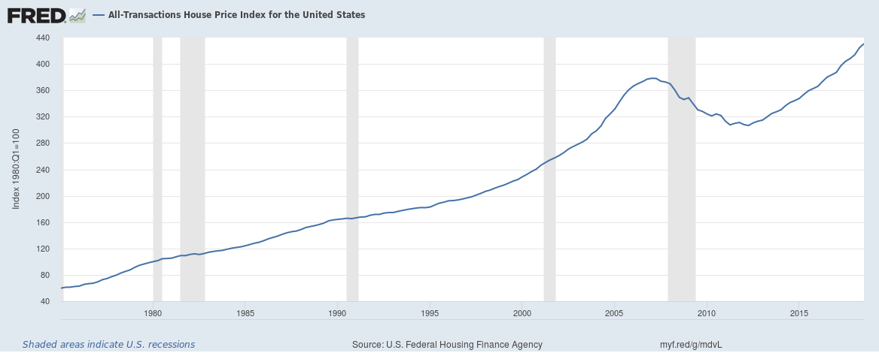

Consider too the text box “The Great Moderation and the 2008-2009 Recession”. Some economists mistook the relatively stable period of the late 1980s-late 1990s (termed “the Great Moderation”) as an indication of the success of policy, rather than the lucky coincidence of an absence of negative shocks. Hubris and complacency are not characteristics of good scientific practice—we must constantly challenge our data and honestly test falsifiable hypotheses if we are to understand a dynamic (changing) and increasing global economy.
Similarly, it would be a mistake to confidently forecast future GDP growth based on a historical production function relating labor to real chain-weighted GDP without considering the impact of technological change and skill-biased growth on labor demand and on labor productivity (see text box “Jobless recoveries”). Economists are constantly updating their estimates of the aggregate production function—for academics as a result of their general thirst for knowledge about the economy, and for professional forecasters to improve the market value of their forecast—but if we become too complacent and too confident in our models, we can easily miss important turning points.

